

**QUAID-E-AWAM UNIVERSITY**  
 OF ENGINEERING, SCIENCE & TECHNOLOGY NAWABSHAH, SINDH, PAKISTAN

**GROUP NAME (Game Changer**)

**PROJECT NAME :** HOSTEL MANAGEMENT SYSTEM

**GROUP LEADER :** SAYED AMJAD ALI SHAH (20IT32)

**TEAM MEMBER 1**: KHAIR MUHAMMAD KANHIO (20IT24)

**TEAM MEMBER 2**: AMJAD ALI (20IT31)

**TEAM MEMBER 3:** ARIF HUSSAIN VIGHIO (20IT49)

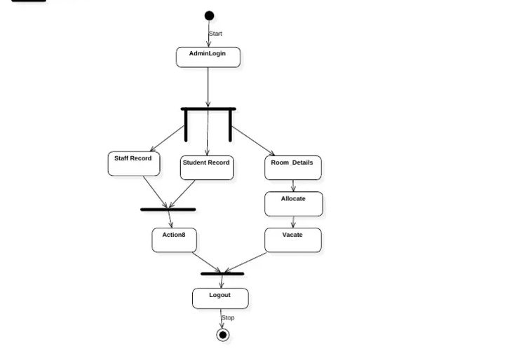

**ACTIVITY DIAGRAM**

**USE CASE DIAGRAM**

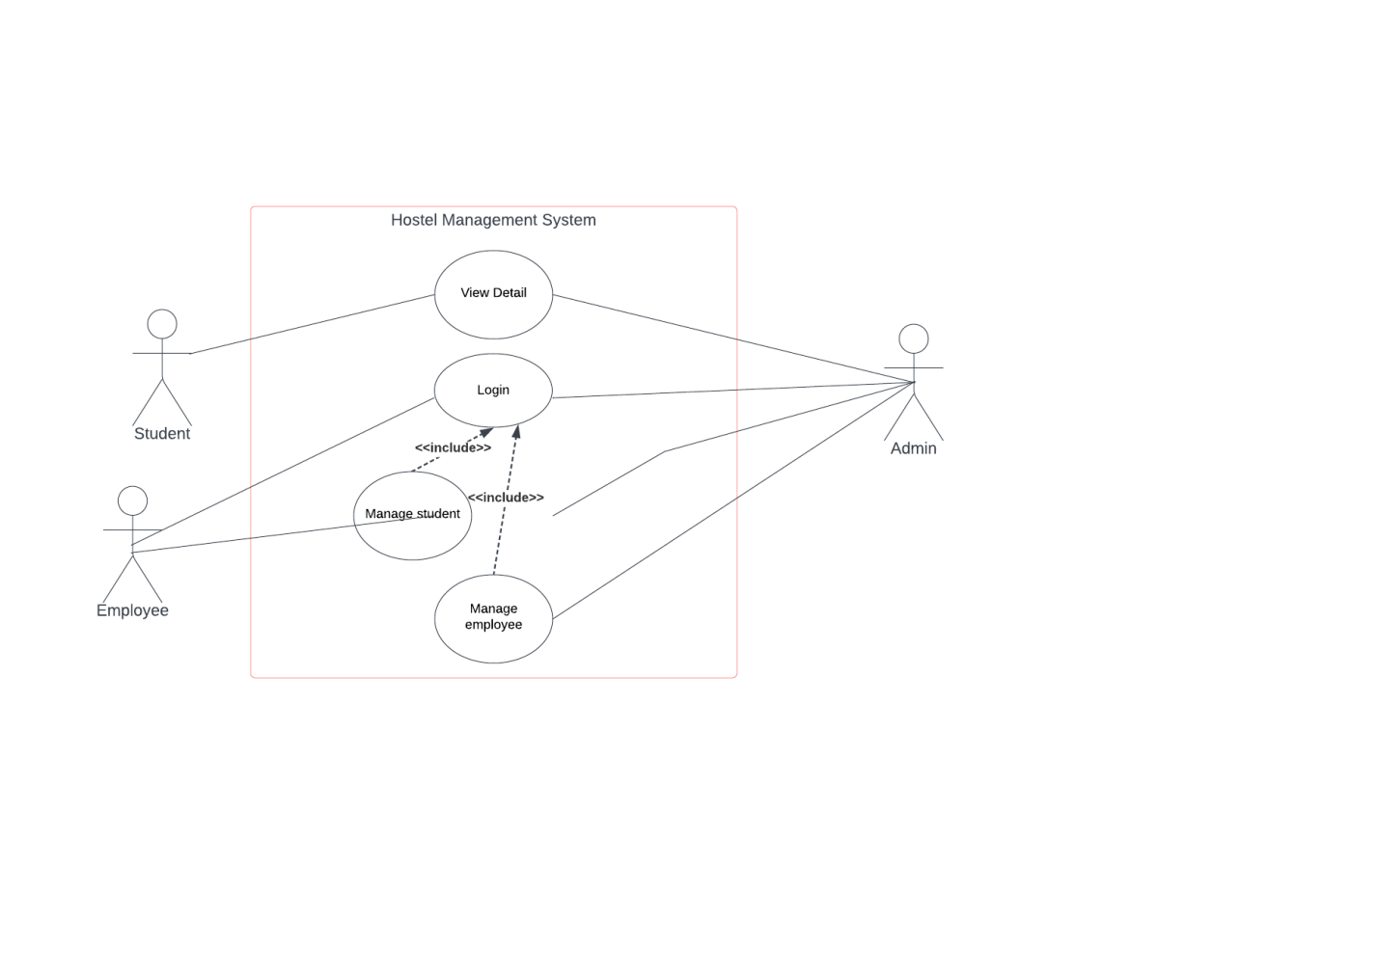

**CLASS DIAGRAM**

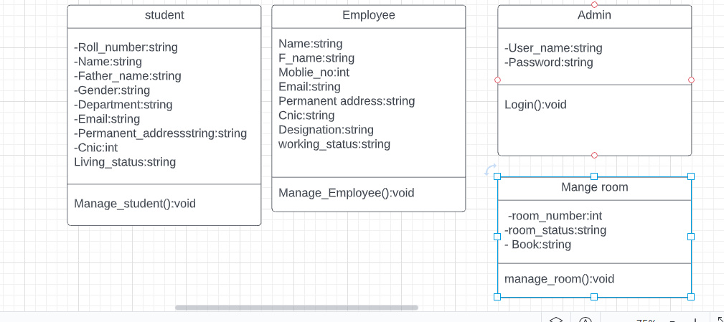

**1. MANAGE ROOM TABLE**

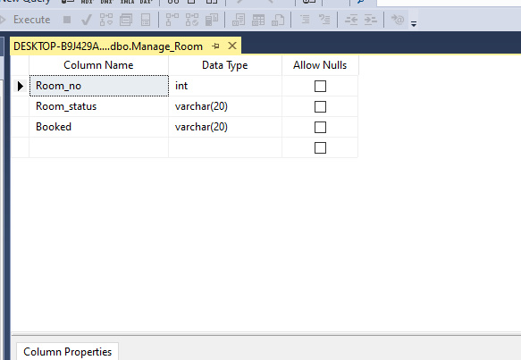

**2. ADMIN TABLE**

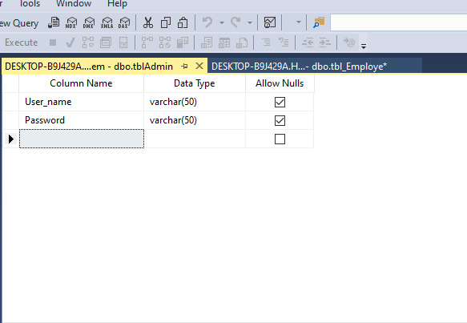

**3. STDENT TABLE**

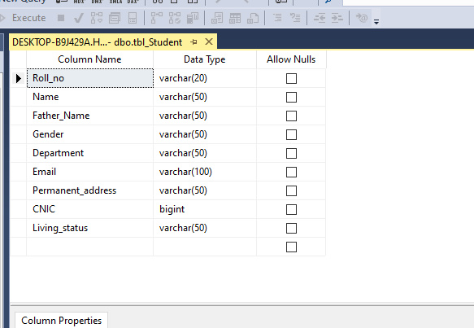

**4. EMPLOYE TABLE**

